CS 305 Module Two Written Assignment Template

Instructions
Replace the bracketed text with the relevant information in your own words. If you choose to include images or supporting materials, make certain to insert them in all the relevant locations in the document.

Areas of Security

There were numerous areas of security I hyper focused on within our server The first and most was input validation. Something else that would be incredibly important is API. Because at the moment sensitive information and passwords are not being handled cryptography is not as important. Now error handling is something incredibly important to any project.

Areas of Security Justification

- Lack of input validation: This is extremely important without input validation or by allowing individuals to input anything into the code block. It makes our code and database vulnerable and allows anyone who knows basic SQL injection a way to cause issues within our database.
- APIs: By not keeping a good enough job managing and handling APIs we expose our code base and ourselves to vulnerabilities that are well known and easily exploited. We also lose out of key updates and security patches that happen to ensure a safer system.
- Error handling: Code will break and handling this break efficiently and adequately is incredibly important doing so one line of code breaking from breaking so many more lines of code. This also keep our code safe and doesn’t allow users to access other parts of the website

Code Review Summary

Input validation:
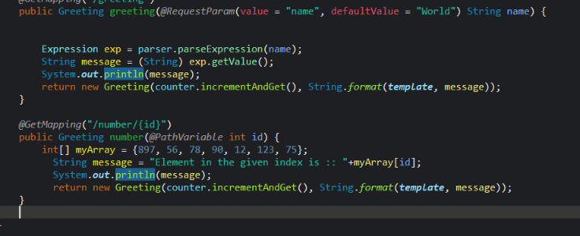
Example of lack of input validation.
APIs:
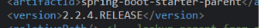
Example of outdated Api.

Error handling:

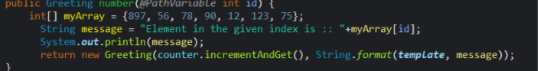
Example of code that may throw an error due to integer overflow and increment should start at -1 due to index rules

Mitigation Plan

- Input Validation: the first is to always treat user submitted data as dangerous until proven otherwise this means having list of banned words, limiting the number of characters allowed in certain inputs, and never passing raw data into the server side. By doing these three things we can prevent user submitted inputs from causing issues within our server.
- API: Always staying up to date on the APIs we’re using and making sure to investigate news of vulnerabilities in our API that get published.
- Error Handling: always handle errors as gracefully as possible. Due to the nature of programming errors are inevitable but by making sure errors are nondestructive and instead safely happen within an enclosed space this can prevent issues from compounding and spreading.

